

**Assignment02**

**Data Warehouse & Business Intelligence**

**2021**

**Submitted By**

**H.R.T.V.Indrahenaka**

**IT19211824**

**Y3S1.15(DS)**

**Step 01. Data source for the assignment 2**

This Dataset is about Android Application of over 48 000 Android Applications.

In the tables have same details Have same details about Android Information (appname, fancyname, category, company, basename, downloads, reviews, rating, LowPriceItem, TopPriceItem, Price, Ads, agerating). So, I have prepared my dataset by breaking them in other tables remains only the appname.

So I used the previously created Android Data warehouse for my Data source in this Reporting project.

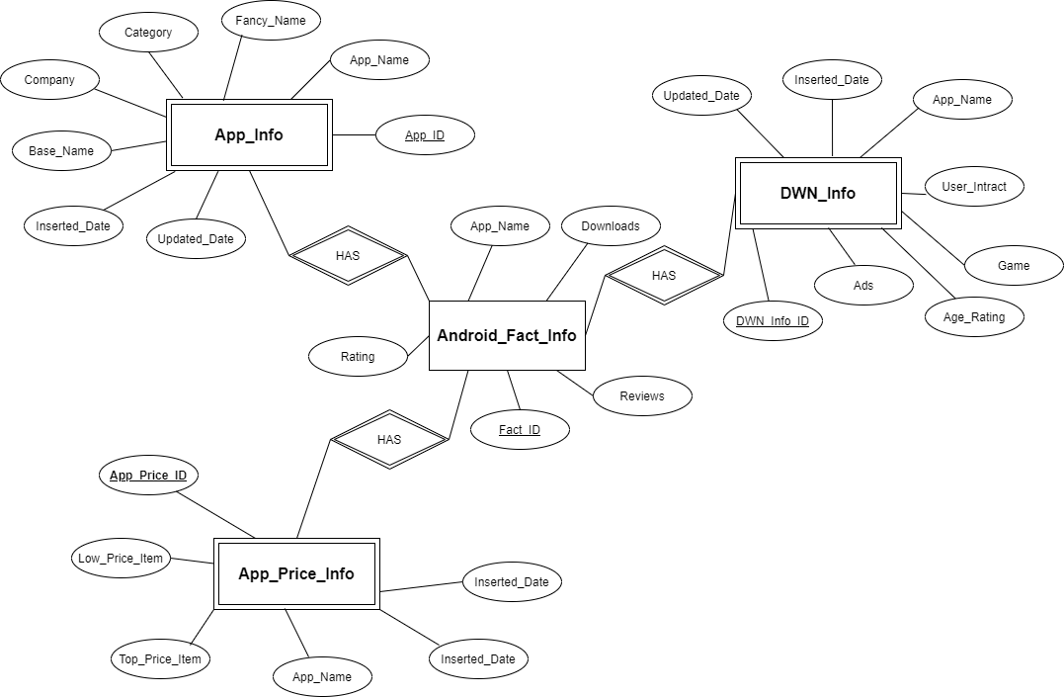**ER Diagram**

*Figure 1.0*

**Step 02: SSAS Cube implementation**

1. First of all Opened Data tool as an Administrator.
2. Then created a new project named “Android SSAS” as a project based on Analysis Services Multidimensional and Data Mining Project.
3. Created a data source by right click on the Data sources on Solution explorer.
4. Create connection to configure and created the data source by using Android DWH.

*Figure 2.0*

1. After that created Data source Views by right click on Data Source Views on solution explorer.
2. Then named it as “dsv_Android_DWH.ds”.
3. By doing so implemented a Cube named as “cube_Android_DWH.cube”.

*Figure 2.1*

1. Then mapped related Dimension tables tables and Fact tables according to the implemented data warehouse.
2. Then created Dimension according to the Data source.

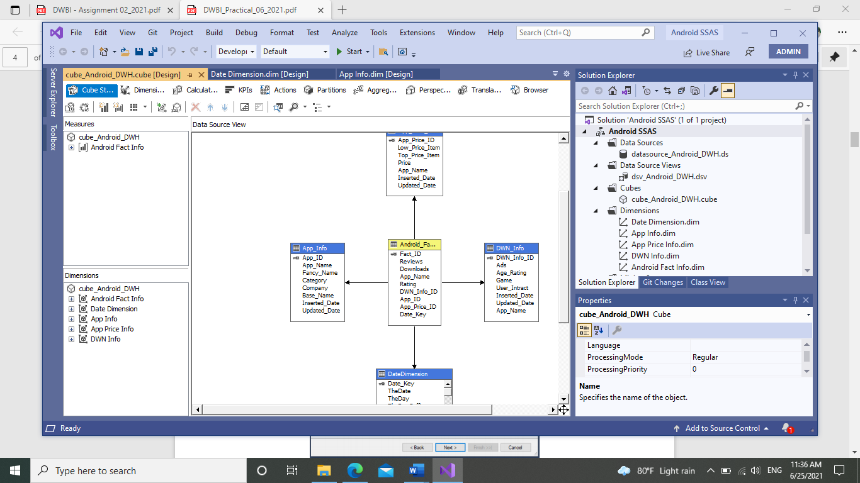

*Figure 2.2*

1. After doing mapping and other related activities I got a picture of my cube.

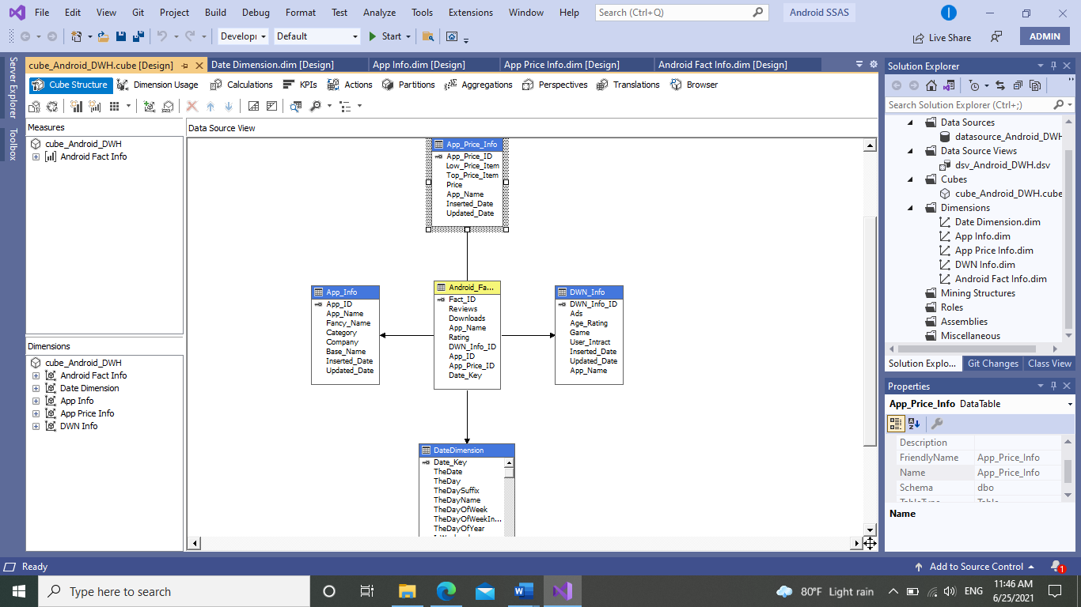

*Figure 2.3*

1. Then created KPIs and other remaining parts by browsing the cube.
2. After doing so, I added those data to SQL Management studio under Analysis.

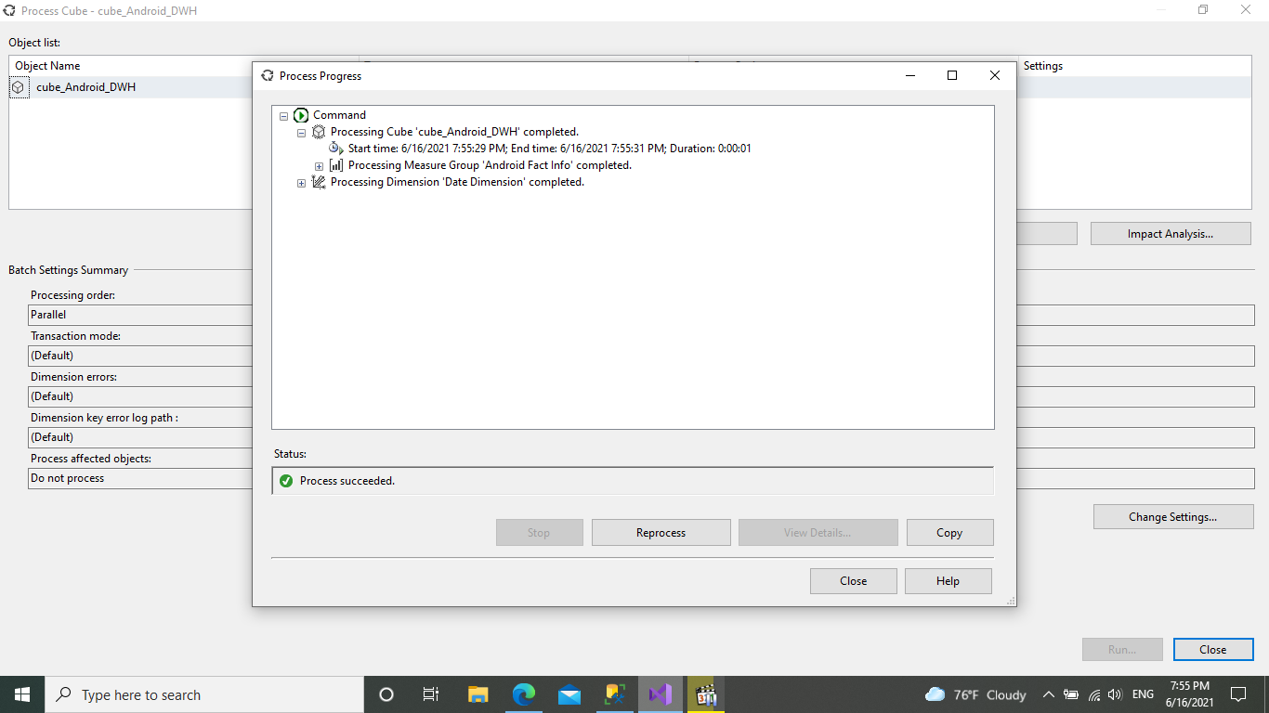

*Figure 2.4*

1. When I tried to deploy the cube, At first I got lot of deployment issues.

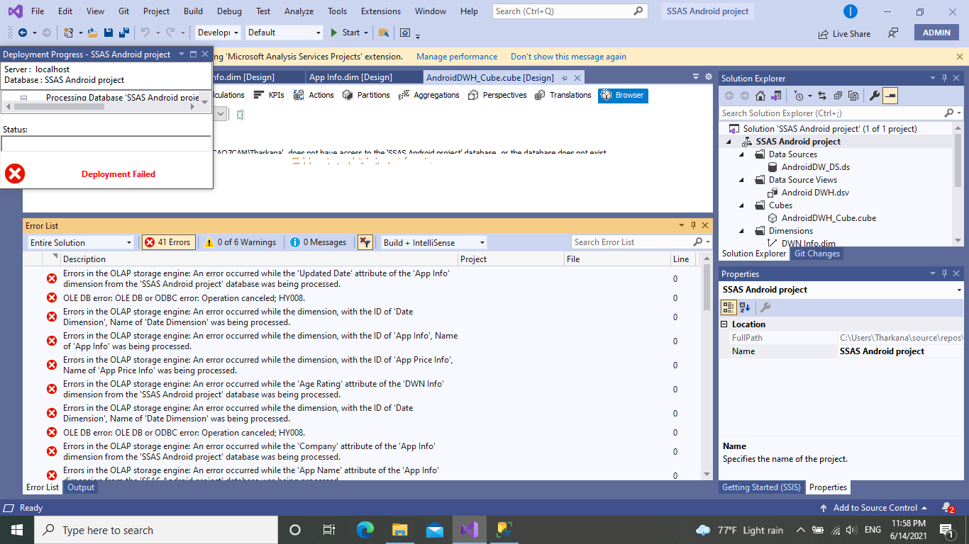

*Figure 2.5*

1. But Finally at the end I managed to resolve those issues and successfully deployed the cube.

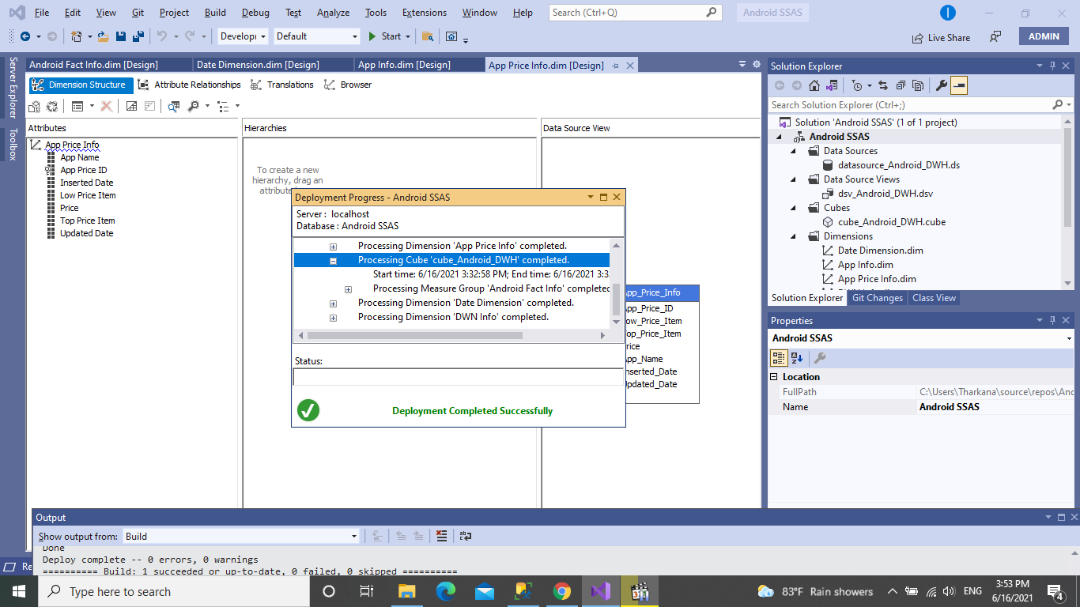

*Figure 2.6*

**Step 03: Get Cube data On to Excel work book(OLAP Processes)**

1. First when I tried to insert my cube data through the SSAS to Powerpivot. It generate lot of issues saying that the Device memory was not enough to do the operation.
2. Then I referred through lot of websites and my badge mate opinions. But neither of them worked.
3. And the query execution was also interrupted due to errors. I cannot show proof to that error because when that error occurs whole device get stucked and stopped working.

But here are some evidence to show that,

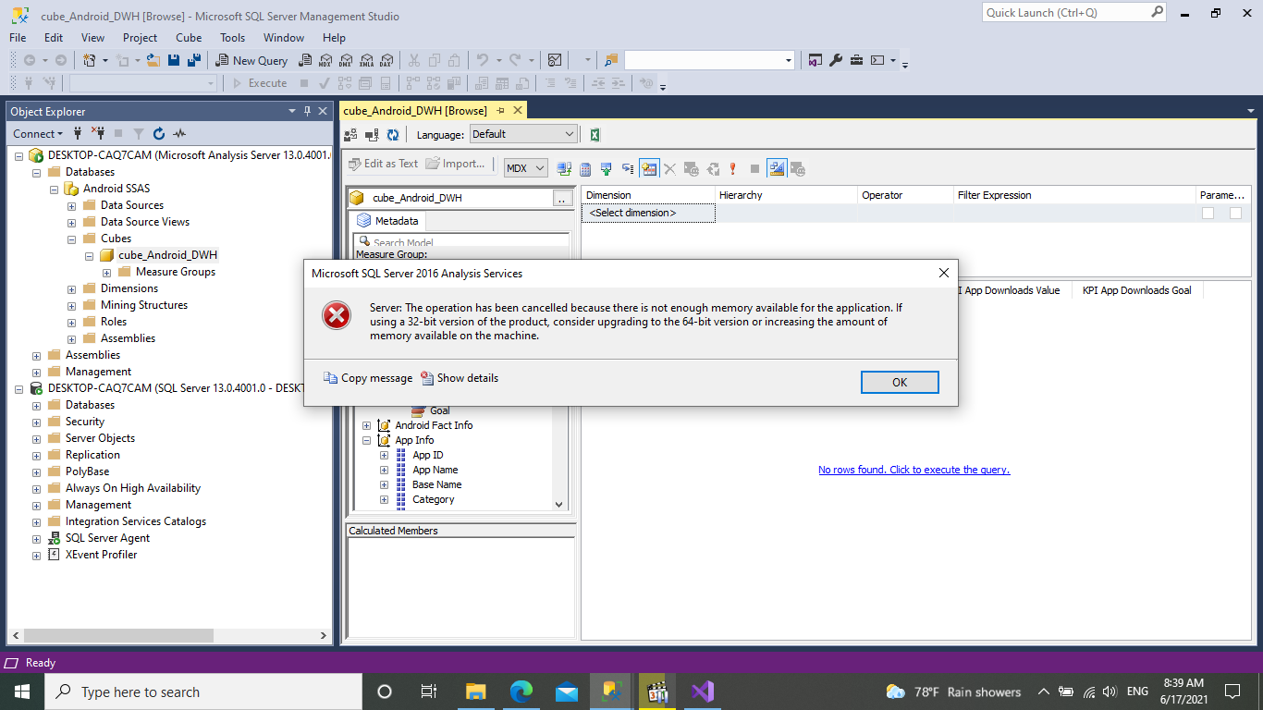

*Figure 3.0*

1. But after trying for several days I can be able to successfully import cube data to powerpivot.

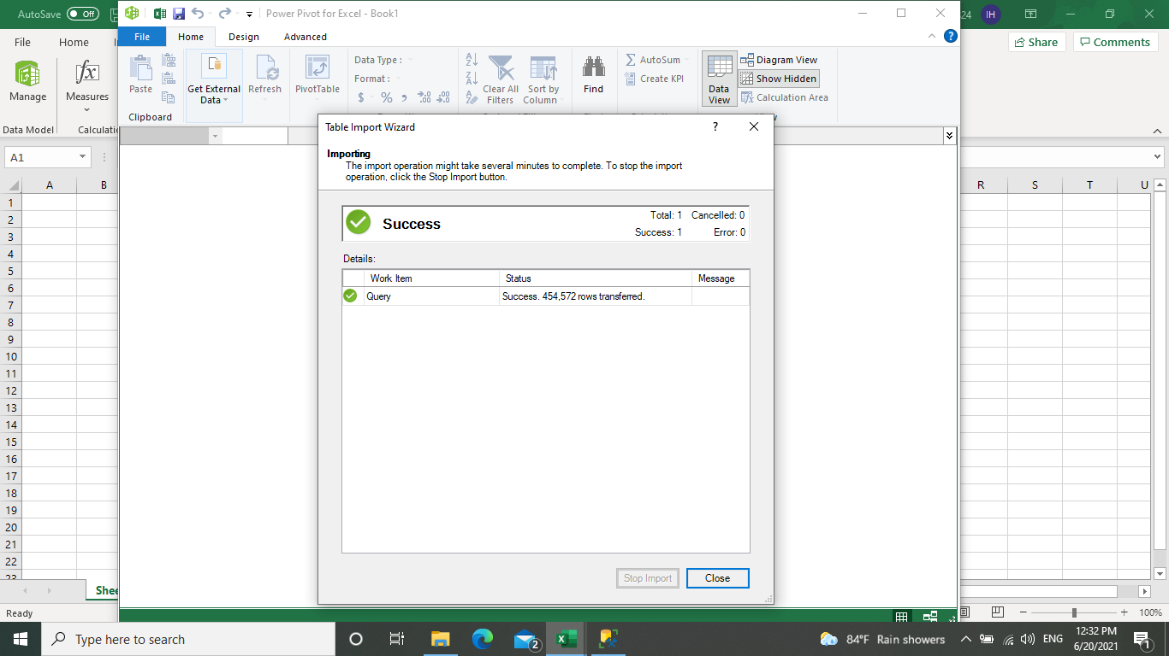

*Figure 3.1*

1. And the other table data got successfully imported too.

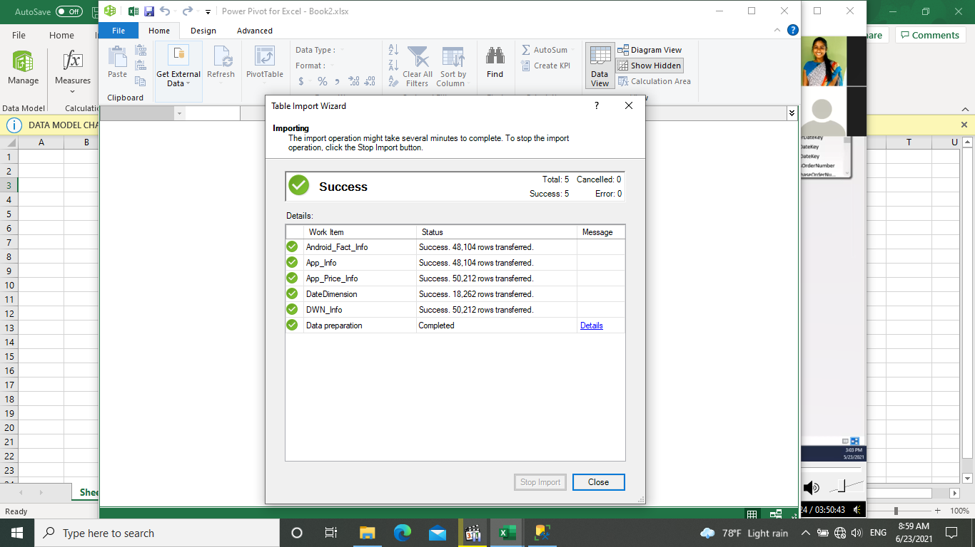

*Figure 3.2*

1. By using those data I created Dashboards by using several OLAP processes like SLICING,DICING etc:

Dashboard 1

*Figure 3.3*

Dashboard 2

*Figure 3.4*

*\*\*To create such Dashboards, I used power view option that build on Excel. Abd charts also generated using those options.*

**Step 04: SSRS Reports**

1. First created Data sources / Data sets and Parameters inside the report builder according to the generating report s
2. So, I created several Reports based on various data
3. Below I mention some of those reports,

* Matrix Reports

(Age rating wise Categories with Downloads)

*Figure 4.0*

* Matrix with one parameter

(Age rating wise Categories with Downloads)

*Figure 4.1*

* Matrix with double parameters

(Categories wise Ratings)

*Figure 4.2*

* Drill through reports

*Figure 4.3*

1. To colour up column values and other charts, I used tools on the report builder and to generate data sets according to reports I used MDX Queries to change and edit data sets and to get new parameters.

*\*\*These reports are generated from Report Builder and these are just samples and all the other reports are on SSRS Reports folder*